NPS Form 10-900 OMB No. 1024-0018
(Rev. Oct. 1990)

United States Department of the Interior
National Park Service

NATIONAL REGISTER OF HISTORIC PLACES

REGISTRATION FORM

1. Name of Property

historic name: Montana State Fairgrounds Racetrack

other name/site number: Lewis and Clark County Fairgrounds Racetrack; Helena Downs

2. Location

street & number: 98 West Custer Avenue not for publication: N/A
vicinity: N/A
city/town: Helena

state: Montana code: MT county: Lewis and Clark code: 049 zip code: 59601

3. State/Federal Agency Certification

As the designated authority under the National Historic Preservation Act of 1986, as amended, I hereby certify that this X nomination request for determination of eligibility meets the documentation standards for registering properties in the National Register of Historic Places and meets the procedural and professional requirements set forth in 36 CFR Part 60. In my opinion, the property X meets does not meet the National Register Criteria. I recommend that this property be considered significant nationally statewide X locally.

Signature of certifying official/Title Date

Montana State Historic Preservation Office
State or Federal agency or bureau ( See continuation sheet for additional comments.)

In my opinion, the property meets does not meet the National Register criteria.

Signature of commenting or other official Date

State or Federal agency and bureau

4. National Park Service Certification

I, hereby certify that this property is: Signature of the Keeper Date of Action

entered in the National Register
see continuation sheet
determined eligible for the National Register
see continuation sheet
determined not eligible for the National Register
see continuation sheet
removed from the National Register
see continuation sheet
other (explain):

Montana State Fairgrounds Racetrack Lewis and Clark County, Montana
Name of Property County and State

5. Classification

Ownership of Property: Public/local

Category of Property: Structure

Number of contributing resources previously
listed in the National Register: N/A

Name of related multiple property listing: N/A
Number of Resources within Property
Contributing Noncontributing
0 2 building(s)
0 0 sites
1 2 structures
0 0 objects
1 4 TOTAL

6. Function or Use

Historic Functions:
RECREATION AND CULTURE/fair
Current Functions:
RECREATION AND CULTURE/rodeo grounds (portion of track and infield)
NOT IN USE

7. Description

Architectural Classification: Materials:
OTHER: racetrack foundation: EARTH
walls:
roof:
other: WOOD (rails); METAL (starter’s gate, stands)

Narrative Description
___________________________________________________________________________________________________________
The Montana State Fairgrounds is located on the west side of the city of Helena, nestled amid mature cottonwoods in the valley below Mount Helena and the Scratchgravel Hills. Within the property there are resources of both modern and historic age, and the racetrack is an elegant structure that constitutes the heart of the fairgrounds. Constructed in 1870, the mile-long track and its massive infield can be found at the northwest side of the fair property.

Racetrack (one contributing structure)
From the south side of the track, spectators enjoy a panoramic view of the Helena valley and the magnificent sight of the Sleeping Giant (also known as Beartooth Mountain) against the northern skyline. The oval, mile-long track is situated east/west with moderate turns at either end. The backstretch is on the north. The home stretch on the south, where the horses exert their greatest effort, is 2 furlongs (¼ mile). The width of the track is about 75 feet; ample room for six to eight sulkies to travel abreast down the stretch. The surface of the track is soil and is banked and elevated. The grass infield is open space to accommodate full view of the entire track. A rail of sturdy 4 x 4s on wooden posts, painted a crisp white, defines the track. Historically, a wooden rail defined the edges of the track, but the existing rail is likely not of historic age. A historic, graded dirt roadway surrounds the track at the east end. Its width is sufficient to accommodate motor vehicles, and it is set below the grade of the track.

Metal Stands and Press Box (two non-contributing structures)
In 1999, temporary, metal-framed stadium seating was introduced in lieu of the original grandstands. In 2005, a small portion of the track, approximately one-eighth of the surface, just east of the homestretch and west of the first turn, was blocked off by metal-framed stands. In order to create a rodeo arena, the track surface was turned, and a section of the infield was denuded of grass. The result is a square-shaped arena, surrounded by metal stands to the south, west, and east, and a tall metal-framed press box at its north side, within the infield. These intrusions, though substantial, are removable, and constitute only a small portion of the track’s overall size.

Rodeo Building (one non contributing building)
In 2005, a small, low, shed-roofed, concrete block building was constructed on the track’s infield just northwest of the press box. The rectangular building rests on a concrete pad foundation. The roof is metal, slopes down to the west, and overhangs the building on the east side. This overhang provides shelter the building’s only openings: a pedestrian door and two metal-framed windows.

Lions Club Concessions Building (one non-contributing building)
In 2005, a small, low, shed-roofed building was moved into the infield just west of the rodeo building. Set on a concrete pad foundation, the wood-framed building has a metal roof that slopes down to the west. The roof overhangs the east side, providing shelter for the concession booth openings. The east elevation features a half-wall across its length, and regularly-spaced dimensional lumber posts define the concession booths. Removable plywood sheets cover the booth openings across the east elevation..

Integrity

Since its construction in 1870, the racetrack has witnessed changes to its setting, as the fair expanded and buildings and structures were added to or removed from the property. Though there is mix of historic and non-historic resources on the grounds, the essential elements of the setting – the open, park-like space dotted with the animal facilities and exhibition halls - are intact. Similarly, the feeling of the massive track itself is intact, as being present there is evocative of its rich historical associations with horseracing in the state. Integrity of design, dating from the 1890 improvements to the track, has been impacted by the construction of the rodeo arena at the southeast one-eighth mile. These changes are substantial but reversible, and the vast majority of the design, materials, and workmanship remain unaltered. Certainly the loss of the grandstands in 1999 was detrimental to the integrity of the overall facility, but the racetrack resource itself is an important testament to the long tradition of racing in Helena and throughout Montana. The track is a large, graceful resource that effectively conveys these significant associations.

Montana State Fairgrounds Racetrack Lewis and Clark County, Montana
Name of Property County and State

8. Statement of Significance

Applicable National Register Criteria: A
Criteria Considerations (Exceptions): N/A
Significant Person(s): N/A
Cultural Affiliation: N/A
Areas of Significance: ENTERTAINMENT/RECREATION
Period(s) of Significance: 1870-1932
Significant Dates: 1870, 1890, 1932
Architect/Builder: Unknown

Narrative Statement of Significance

Summary Statement of Significance
Constructed in 1870, the historic racetrack at the Montana State Fairgrounds constitutes a significant link to the proud history of horseracing in the city of Helena, and throughout the state of Montana. One of the earliest regulation tracks to be built, the resource has a long and important history as the center of recreational racing in the area. As the location of the first organized and regulation races in the state, the fairgrounds track is the place where the colorful and important history of Montana horseracing got its start. Throughout the late 1800s, Helena’s track was intrinsic to the state’s racing circuit, where breeders, horses and jockeys influenced the national racing scene. Throughout the years, and especially during the State Fair’s heydays between 1870 and 1932, racing at the track was attractive to elite thoroughbred aficionados as well as standardbred enthusiasts. For these reasons, the Montana State Fairgrounds Racetrack is eligible for listing in the National Register of Historic Places under Criterion A.
General History of Horseracing
Horseracing as a sport is as old as the most ancient civilizations, recorded in the earliest written records. Chariot and mounted horse racing were included in the Greek Olympics as early as 638 BC. Twelfth century crusaders planted the seeds of modern racing when these English knights returned home with Arab horses. The importation of Arab stallions to be bred with English mares over the course of the next four centuries produced faster horses with greater endurance and prompted the nobility to begin private wagers for two-horse races.
Horse racing achieved professional status in the early eighteenth century during the reign of Queen Anne. Racecourses soon dotted England and wagering among spectators made the sport profitable for owners with the best horses. Breeding programs took advantage of methods stemming from new scientific investigations during this century’s Age of Enlightenment.
The Jockey Club organized in 1750 to write the rules and standards of the sport and regulate the breeding of racehorses. In 1791, James Weatherby—whose family served as accountants to Jockey Club members—introduced the General Stud Book. Weatherby’s research recorded the pedigrees of each of the 387 horses racing in England at the time. These horses all traced their lineage back to three Arab stallions imported from Syria and Turkey in the seventeenth and eighteenth centuries. Within a decade of the introduction of the stud book, only horses descended from those listed in the book could be called thoroughbreds. Even today, English thoroughbreds trace their lineage to one of these three stallions, or “foundation sires:” Byerly Turk, Godolphin Arabian, and Darley Arabian. The Weatherby family continues to keep this record today.1

American Horse Racing
British colonists brought horses and the sport of horse racing to the New World. In 1665, Long Island was the site of the first American racecourse. But while racing was a favorite pastime among the colonists, the sport was unorganized until 1745 when Governor Sam Ogle of Maryland organized the first regulated race at Annapolis. This organized race prompted breeding programs using English pedigreed horses. The Revolutionary War ended the importation of British stock. After the war, importation of English breeding stock began again in earnest, especially in the southern states.
The Civil War again decimated stock and breeding programs, but horse racing bounced back to regain and surpass its previous popularity. The American Stud Book, based on the English model, began in 1868. By 1890, the United States boasted 314 tracks.
Corruption within the sport prompted prominent track and stable owners to organize the American Jockey Club in 1894 to oversee the rules and control illegalities. This entity still has authority over the breeding of American thoroughbreds.2 Thoroughbred horses historically raced under saddle on flat courses over distances varying from three-quarters of a mile to two miles.

Thoroughbred racing was a sport of the elite, while trotting horse races gained great popularity in the United States as a sport of the common man. At a time when almost everyone owned at least a horse or two, neighbors took pleasure racing each other, their horses trotting or pacing swiftly afore the family carriage or buggy. Neighbors racing neighbors on county backroads led to driving races in county fairs. As trotting and pacing horses gained great popularity in mid-nineteenth century America, the desire for horses bred to the sport led to the evolution of the standardbred horse.
While English thoroughbreds trace their ancestry back to the three Arabian stallions, the standardbred traces its lineage to Messenger, a descendant of one of the three foundation sires stallions, Darley Arabian. Messenger’s sire, Mambrino, was the founder of a grand line of English trotting coach horses. Messenger’s owner, Thomas Benger, brought him to the United States in 1788. Henry Astor, brother of wealthy John Jacob Astor, later purchased him.
Messenger was bred to thoroughbred and mixed breed mares. A new breed emerged suited by temperament, endurance, and anatomy to racing under harness. Standardbred horses were so-named in 1879 for the practice of basing their harness racing speeds on the “standard” distance of one mile. One-mile tracks sprang up across the United States to accommodate trotters and pacers. Bloodlines included Morgan, Clay, Mambrino, Hambletonian and others. Within the next several decades, Hambletonian horses surpassed some of the other bloodlines, including Morgan, Clay, and Mambrino challengers.3
Across the United States, tracks for racing under saddle and under harness grew in popularity during the 1860s. Tracks first operated independently. A desire to coordinate racing schedules led to better organization so that horses and their trainers could move from track to track during the season, or year-round. Among the famous yearly thoroughbred races were the three that together form the Triple Crown. All three races remain premier events today. New York’s Belmont Stakes was first run in 1866; the Preakness premiered at Maryland’s Pimlico racecourse in 1873; and the first Kentucky Derby was run at newly opened Churchill Downs in 1875.
By the 1870s, trotters and pacers also moved from track to track with the racing schedule. In 1871, a group representing three racetracks met in Ohio to establish the Grand Circuit. The yearlong schedule included sixty tracks across the nation with a total purse of $169,300.4

Racing in Montana
Native Americans brought horses into Montana in the 1700s, and racing from that time was a common sport. The tiny town of Racetrack near Deer Lodge takes its name from the long straightaway where, according to local tradition, Indians raced their ponies. It is likely that native people brought the first thoroughbreds into Montana. Billy Bay, a Kentucky thoroughbred stallion, is one of the first to appear by name in the written record. Several sources mention the famous Billy Bay, reputedly taken from the area north of Salt Lake and brought to the territory by Blackfeet. Trader Malcolm Clarke, whose wife was a Piegan Indian, and likely acquired the horse through his in-laws. Money, furs, and other valuables had been staked on Billy Bay in inter-tribal races.5
Horse racing was a popular sport among the miners from the very beginning, and races in the streets of the mining camps were common past times. Mrs. Jack Slade purchased Billy Bay from Malcolm Clarke and was a frequent contender in the weekly Sunday races held in the streets of Virginia City. In fact, it was on Billy Bay that Virginia Slade made her famous, futile ride to save the life of her husband, hanged by the vigilantes in March of 1864.6
If a person owned a fast horse, he would travel around to the mining camps looking for challengers and wagers. Johnny Grant, who brought horses into the Deer Lodge Valley he acquired from immigrants along the Oregon Trail, made these circuits. In November of 1864, Grant advertised in the Montana Post that his mare, Limber Belle, would race anywhere in the territory.7
As the territory began to develop its agricultural potential, a number of prominent early settlers began to raise blooded horses. While many early Montana settlers including Conrad Kohrs and John Bielenberg owned blooded racehorses, Morgan Evans and S.E. Larabie in the Deer Lodge Valley, Silas Harvey at Clancy, and Robert Vaughn of the Sun River valley were among the earliest breeders of standardbred and thoroughbred racing stock in Montana.
Early Montana breeders
Morgan Evans, born in Wales, learned the trade of shoemaker. He and his wife, Ann, came to the United States in 1856. They headed west to Salt Lake where Evans practiced his trade and farmed until 1864 when he began freighting between Salt Lake City and Virginia City, Montana Territory. Evans brought his large family to the Deer Lodge Valley in 1865 where he acquired acreage through purchase and homestead claims. By 1885, Evans had 1,000 acres under fence and a herd of 100 horses including Mambrino and Morgan stallions and Mambrino brood mares.8
S. E. Larabie was a prominent, wealthy Deer Lodge banker whose hobby was raising fine thoroughbreds for racing. A native of New York, he arrived at Alder Gulch in 1864 and settled in Deer Lodge in 1866. In 1880, Larabie established the Willow Brook racing farm. Larabie’s farm included barns and paddocks where the horses could run during the day. Larabie was adamant that his horses were never without shelter at night. At first Larabie favored standardbred Morgan, Mambrino, and Hambletonian horses. But the success of neighbors Conrad Kohrs and John Bielenberg with thoroughbreds led Larabie to found the racing firm of Eastin and Larabie in 1886. The firm maintained its training stables at Lexington, Kentucky. Larabie remained in Deer Lodge and reportedly saw his partner only several times, but Larabie bred some famous horses at Willow Brook and had them trained at the Kentucky stables. In 1900, Larabie sold his Kentucky operation to James Ben Ali Haggin, one of Marcus Daly’s business partners.9 However, racing programs show that Larabie continued to run his Montana horses at the Helena track.
Silas S. Harvey came to Montana Territory in 1867 to take charge of the Diamond City Mining Company Works. After the company disbanded in 1870, Harvey established the Red Cliff Breeding Farm in Clancy. He brought Mambrino-Clay trotting stock from Kentucky, including the renowned Black Diamond (a.k.a. Mambrino Diamond), for breeding and racing under harness. Harvey employed a professional trainer and maintained top-notch facilities. When Silas Harvey died of consumption in 1879, his wife and the Harveys’ sons continued to run Red Cliff and race the horses until financial difficulties forced the sale of the property to Helena banker Aaron Hershfield. An 1888 bill of sale shows that Mrs. Harvey sold four stallions and sixty-six mares and colts to Hershfield for $10,000. Hershfield eventually acquired the farm and sold it to the Haynes family in 1892.10 The Hayneses subsequently ran a dairy farm at Red Cliff.
Robert Vaughn crossed the plains with a wagon train and came to Alder Gulch in 1864 where he made a living buying livestock and selling meat to the miners. By 1869 he had made enough money to settle on a farm in the Sun River valley where he was the first in that region to raise highbred horses and cattle. Over the next several decades, Vaughn raised some of the region’s best trotters. His stock was almost always among the winners of the races at the Territorial Fairs in Helena.11

Montana’s National Contributions to the Sport
Racing programs beginning in 1870 at the Territorial Fairs in Helena paved the way for the racing industry to blossom in Montana. Big money racetracks later at Butte and then at Anaconda, where Marcus Daly built his track in 1888, put Montana racing on the national map. At first these tracks mostly held trotting races. But then Anaconda’s track was a proving ground for Daly’s own famous thoroughbreds and trotters, and trainers and jockeys came from all over the country to race there. Daly’s sponsorship of Anaconda’s racing program took the sport to high levels in Montana. The races there and at Butte, considered the best the West could offer, were covered in the national racing news. All the national scores, received by telegraph, were updated and posted on chalkboards at designated locations in both towns.12 Neither the Butte nor the Anaconda tracks survive.
Some Montanans were involved in high stake races and their stock made the national circuits. S. E. Larabie’s Montana–bred Ben Holladay won many national races including the Morris Park handicap in 1898. That same year the Spirit of the Times, a prestigious publication devoted to racing, said of Larabie, “...no other owner had bred so many high class race horses from so few mares.” Other Larabie-bred horses of distinction included Poet Scout, Decapod, and Halma, all of whom took first places in national high stakes races.13
Noah Armstrong kept and bred thoroughbreds as a hobby and had a track on his ranch near Twin Bridges in Madison County. Armstrong made a fortune in mining and invested some of his wealth in raising and racing thoroughbreds. His huge round barn with the sheltered quarter-mile track still stands. There the famous Spokane was born and trained. Spokane had made the western circuit only briefly when he ran the 15th Kentucky Derby in 1889. Bookies overlooked him at 6 to 1 odds, favoring Proctor Knott, a proven winner. Spokane made racing history. He passed Proctor Knott to win by a head, breaking the previous Derby record.14
Copper king Marcus Daly got into the business of breeding and racing his horses in 1887 when he established the Bitter Root Stock Farm near Hamilton. One of Daly’s business partners, San Francisco attorney James Ben Ali Haggin, was a native Kentuckian whose family was prominent in the horse racing business. Perhaps because of his association with Haggin and with A. B. Hammond, a prominent Missoula equine enthusiast, Daly became interested and came to believe that the Bitterroot valley was the ideal place to breed and train trotters and thoroughbreds. It was ideal partly because of the lush grass that grew there and reminded Daly of the Emerald Isle where he was born. But also Daly figured that horses raised and trained at higher altitudes were stronger and developed more stamina. He built the best facilities and an indoor racetrack, importing veterinarians, trainers, and young African American jockeys ages 8 to 15 to exercise and ride the horses.15
Daly's Bitter Root Stock Farm produced some remarkable champions. Trotters Ponce de Leon, China Silk, and Prodigal won substantial purses. But his thoroughbreds made his stables nationally famous. Montana (Suburban winner, 1892), Ogden (Futurity winner, 1896), and Tammany were among the best. Most of Daly’s horses raced at Anaconda’s track. Of these, Tammany was the most famous of all. He won both the Lawrence Realization and Withers Stake races at New York's Belmont Park in 1892. In 1893, a crowd of 15,000 witnessed Tammany defeat Lamplighter by four lengths in a legendary match race at New Jersey's Guttenberg track. Jockey Snapper Garrison (who also rode Montana to a smash finish in the Suburban handicap in 1892) led Tammany to such a breathtaking finish that it became known as a Garrison finish, a term defined in Webster’s dictionary. The win established Tammany as the East’s best thoroughbred racer from 1892 to 1894.16
Daly built Tammany Castle for his gentle champion and favorite pet; it presides at the top of a long, graceful drive. Cork floors half a foot thick imported from Spain protected the stallions from slipping, and the heated stalls were lined with velvet. At his Montana Hotel in Anaconda, a mosaic of Tammany graced the lobby where one dared not step on the revered horse’s head.
After Daly’s death in 1900, his string of nearly two hundred thoroughbreds were auctioned at a dispersal sale at Madison Square Garden in New York City and in San Francisco. James Ben Ali Haggin purchased some of them. The total price of Daly's horses was the most impressive dispersal of racing stock in American history. Daly’s Bitter Root stock bloodlines went on to produce many notable animals including Kentucky Derby winners Regret, Paul Jones, Zev, and Flying Ebony.

Racing at the Lewis and Clark County Fairgrounds
Horse racing in Montana evolved into big business, dominated by Montana’s wealthiest men as both owners and breeders of famous horses. The sport also appealed to the working force and early Montana newspapers are packed with racing news both national and local. But the industry’s roots were planted first in individual communities including Virginia City, Deer Lodge and Helena during the 1860s. In these remote places rather informal racetracks encouraged recreational racing and friendly wagering among local and regional contenders.
The construction of the Lewis and Clark County Fairgrounds and the founding of the Territorial Fairs in Helena are of great historical import to the colorful history of racing in Montana. The Lewis and Clark County Fairgrounds track brought larger purses and the first organized races. Entries grew to include a wide geographic area. The facility was also the first and only regulation one-mile racetrack in the state.
Helena’s local racetrack was first located at Madam Coady’s (a.k.a. Cody) Two Mile House “two miles from Helena on the Hot Spring Road.” This may be the site where in 1869, Ferdinand Wassweiler acquired a hot springs hotel (NR listed 8/1/1978), today on Highway 12 West. Madam Coady advertised “A No. 1 Circular Race Course, 1 Mile in Length” that adjoined the house. She billed her establishment as the “favorite resort of pleasure seekers” offering first class meals, accommodations for parties and guests, horse training and boarding stables. The name of the establishment seems to have soon become the “Ten Mile House.” According to local tradition, Mrs. Coady did not approve of horse races, but she was so impressed with a personal visit from Governor Green Clay Smith that he easily persuaded her to change her position. The racetrack, called the Fashion Course, became the site of the first Territorial Fair in 1868. The Montana Agricultural, Mechanical and Mineral Association, a private organization, leased the racetrack for five hundred dollars and erected three buildings to house entries and displays. Funds of $5,000 raised by public subscription paid for the buildings.17
The First Annual Territorial Fair at the Fashion Course marked the first regionally organized horse racing in Montana Territory. Beginning on October 5th, 1868, there was a week of festivities at the Ten Mile facilities that included the first public exhibition of Montana produce. The Helena Weekly Herald invited everyone’s participation. Stage lines offered half-fares for all those coming and going throughout the week. The fair paid premiums on winning entries, with the main horse race paying out a purse of $200. The paper noted entries of “some fine running animals.”18
The following year the second territorial fair at the Fashion Course included an expanded horse-racing program with both trotting and flat racing events open to “all the horses in the territory.” The trotting events paid the highest purses, $200 and $100.19
The fair association reorganized as the Montana Mineral & Agricultural Association in August of 1870, purchasing property north of Helena near the Hebrew Cemetery (Home of Peace, NR listed 5/24/2006). Association Trustees were all prominent Montanans: C. W. Mather, John Kinna, Hugh Kirkendall, Cornelius Hedges, A. M. Holter, D. C. Corbin, D. A. G. Flowerree, Conrad Kohrs, and J. F. Forbis. Representatives from each of the territory’s nine existing counties served on a committee to circulate the agreement and obtain signatures of those wishing to buy stock in the fairgrounds.20 It was, however, a private venture.
On September 15, 1870, the Board of Trustees met and voted to adopt the rules of the American Horse Congress to govern the trotting races and the rules of the California State Agricultural Society to govern the running races. Helena Herald reported on September 24, 1870, that the grounds were finished. The paper declared the racetrack the “finest in the territory,” the “home-stretch, just a quarter mile in length,” said the Herald, “is almost perfectly straight.” The opening of the track continued the territorial fair tradition established two years previous.
The first Territorial Fair at the new Lewis and Clark County Fairgrounds opened for a week of festivities on September 28, 1870. Racing enthusiasts brought horses from as far away as Salt Lake City as well as from communities in the territory including Deer Lodge and Bozeman to compete in running and trotting events. Among the various races, the largest purse was for the six hundred yard dash. Hugh Kirkendall’s Nellie won $400, the largest purse to date. Complaints, however, reveal that the rules were not strictly enforced. Start times were not upheld, and horses arrived after the posted times causing long delays and unorganized races. The associations received criticism in the press for this lack of adherence to start times.21 This underscores the lack of racing organization nationally in the post-Civil War period. Montana Territory follows the national trend, becoming better equipped and better organized each year as the association gained experience and the sport increased in popularity on the national level. Although most communities across Montana had racetracks, Helena’s track continued to be the only regulation one-mile track in the territory.
Races were held at times other than during the territorial fairs. During several days over the Fourth of July, 1871, there was a full racing program. The 1877 fair noted a long list of “imported thoroughbreds and native horses,” many of them from Kentucky. S. E. Larabie, William H. Ewing, J. S. Pemberton, Elijah Dunphy, and O. J. Salisbury were among the well-known Montana owners. As the decade wore on, racing in the territory became more stringent and rules better enforced. By 1884, Helena was part of the Montana circuit that included Butte and Bozeman. Helena, however, boasted two racing programs, one in July and one during the fair in September. Races were no longer open to all horses, but rather the entrants had to go through a nomination process to be accepted to race.22
After statehood in 1889, the fair became the State Fair, although not affiliated with Montana government, and improvements to the track, buildings, and grounds as well as trolley service from town for 25 cents encouraged more participation. Some objected to the focus on horse racing. In 1890, the Helena Daily Herald chastised the public, “These fairs should be patronized more generally by our people interested in things other than horse racing.” Racing enthusiasts countered, “Those who criticize this strain are the very ones responsible for this condition of things.” In other words, it was the horse racing that helped fund the fairs, and if some would complain, they should find other means to fund the event. Nevertheless, multiple purses of $300, $500, and $1,000 in the various categories of trotting and running emphasize the importance of these races and the Helena track.23
By the 1890s, races at the Helena fairs were big business, attracting owners and horses from Deer Lodge; Great Falls; Butte; Toston; Helena; Spokane Falls, Washington; and Denver, Colorado. At the First State Fair in 1890 (although still there was no state involvement), the Denver Trotting Stables had numerous entries. The Denver horses and other jockeys and horses that had been at races at Butte, some 100 in all, arrived with some fanfare on special Montana Central cars built for transporting racehorses.24 An aggregate purse of $15,000 and mutual and other kinds of betting were incentives for numerous entries in 1890. The Daily Independent noted:
The improvements made at the fairgrounds represent an expenditure of about $12,000, the most important being the building of the new track and fencing it in. The new fence has been whitewashed as well as all the inside rails, which, with the green pasture on the inside, presents a cheerful view. Helena has the only regulation racecourse in the state; it is as smooth as a billiard table… 25
Local tradition has it that carloads of imported Kentucky earth were spread on the track. While a spur line did extend to the fairgrounds making this possible, the importation of Kentucky sod remains undocumented.
The Helena racetrack always attracted some of the best horses and jockeys. The State Fair in 1891 drew owners, horses, and jockeys from Miles City and Dillon in Montana, the Suison Stock Farm in California, and from Idaho, Oregon, Nevada, and Kansas City. Copper king W. A. Clark, rancher Morgan Evans, and future senator Lee Mantle all entered horses as did the local well-known teamster Hugh Kirkendall. Kirkendall was one local Helenan who had horses entered in nearly every territorial and state fair from the beginning. The listing of horses’ pedigrees reveals second-generation racers from the horses of the 1870s. For example, Mambrino Diamond, formerly of Silas Harvey’s Red Cliff Breeding Farm (see above), sired Kirkendall’s horse Dollie. Money flowed like water into the pool boxes. At least one trotting race sent “a good many people away broke.”26
Racing continued through 1896 when the last fair of the nineteenth century was held. Racing and the attendant state fairs in Helena lapsed until 1903. This was partly because of the economic slowdown related to the Silver Panic of 1893 that devastated Montana in the 1890s but more importantly because thoroughbred racing had grown rapidly without a central governing authority. Corrupt betting practices attracted a criminal element, reformers criticized the industry, and racing fell out of favor. The American Jockey Club formed in 1894 and quickly cleaned up the criminal element that had dominated the tracks, but the decline continued at the Helena track until its rebound in 1903. Similarly, standardbred or harness racing peaked nationally in the 1890s then began to fall out of favor in the twentieth century as the automobile replaced the horse. The Helena track reflects this national trend.
On May 15, 1891, the fairgrounds property sold at auction for $50,000. The buyer was attorney W. E. Cullen acting on behalf of the Montana State Fair, the successor to the previous longtime owner, the Montana Agricultural, Mineral, and Mechanical Association. The change in ownership from one private group to another may have been simply to accommodate the change from territorial fair to state fair. The two groups had common members. The new group called its event the State Fair, but it had no connection to the state nor did the previous fairs have any connection with territorial government. The new State Fair operators borrowed against the fairgrounds property during the depressed 1890s consistently until 1896, when the last fair was held. Several other individuals then owned the property until 1903.27 During this period when the fairs lapsed, the grounds fell into disrepair. According to some, the railroad eventually further contributed to Helena’s lapse in hosting the fair. Direct service from Great Falls to Billings bypassing Helena made a stop unnecessary. These and other communities began to host their own events.

Horse Racing at the Lewis & Clark Track in the Twentieth Century
The State of Montana purchased the fairgrounds and began to subsidize the fair in 1903. Wild West events, not yet called “rodeo,” were introduced. These included bronco busting and bull dogging. The Montana Weekly Herald of September 24, 1903 noted that a “Rough Riding Contest” with pay out premiums was to be a major event by popular request along with both running and harness racing. Although horse racing was still important to the fairs, other kinds of horse riding events, held in front of the grandstand, drew huge crowds to the track and may have served to assuage those citizens critical of horse racing.
In 1904, the Capital Stock Food Company of Helena sponsored a new kind of event inspired by Buffalo Bill Cody’s “Pony Express Race.” In the Montana version of the relay, racers rode only thoroughbreds and distances varied. Riders changed horses and sometimes their own saddles at top speed. Fannie Sperry Steele, who later became the Lady Bucking Horse Champion of the World, rode Montana’s the first relay race in Helena at the Fairgrounds racetrack. Over the next few years, these races were popular events. Fannie, Christine Synness, and several others, known as the “Montana Girls,” rode relays at Helena, Butte, Anaconda and across the Midwest. Years later in 1975 at age 88, Fannie was one of the first of three women inducted into the Rodeo Hall of Fame, but she got her start at the Lewis and Clark County Fairgrounds racetrack. .In a session held after the close of the 1914 State Fair, the Montana legislature passed a statute that prohibited betting on horse races. This cut off the fair’s main source of revenue. Then in 1915, the legislature cut the maintenance appropriation for the fairgrounds. 28 These changes took a toll on the fair’s finances for the next decade. In addition, poor crops put a damper on the fair’s produce displays. The fair began to decline.
Automobile racing began in 1914 and gained popularity in 1915. An automobile track was constructed within the racetrack in 1916, but horse racing—despite the abolishment of betting—was still a popular facet of the state fair through the 1920s. It waned as the decade passed the mid-mark and again gained momentum in 1927. Carloads of thoroughbreds arrived via the Northern Pacific and the Great Northern and racing enthusiasts hung on the fence around the track, watching the horses’ daily workouts. Nat Hall, editor of the American Racing Record, declared some of the thoroughbreds among the best running stock in the United States. 29 Among the spectators with weeklong boxes in the grandstand were Governor J. E. Erickson, the T. C. Power Company, C. B. Power, Dr. B. C. Brooke, A. B. Cooke, Louis Penwell, and Mrs. Conrad Kohrs. In 1929, over 200 thoroughbreds and a special string from Miles City came by train from fairs all over the state for the opening races.
In 1930, horse racing was again the most important attraction and betting had resumed. Seven races daily for six days made a rigorous program. In July, horses, jockeys and trainers began to gather for the fair, August 18-23. By the 21st of July, “more than 250 horses from the best circuits in Canada, Mexico, and the United States” were stabled at the fairgrounds with 100 more horses due to arrive. The races promised generous purses and the pari-mutuel machine system of betting “added zest” to the finish line. In this system, a machine registers bets as they are placed and calculates and posts changing odds and final payoffs, making races even more exciting. Nearly 25,000 people attended the fair. 30
In 1931, again horse racing was an important part of the program. The Lewis and Clark Racing Association held a “race meeting” at the fairgrounds for six days in early August of 1931 under the new pari-mutuel machine system. 31 The fair then opened ten days later. Six days of races during the fair included purses of more than $13,500. 32 The state fair, however, last held in 1932, lapsed during the depression.
In 1933, the depression forced cancellation of the Montana State Fair at Helena. Most people simply could not afford the price of admission. The Northern Montana Fair was held at Great Falls. At the opening ceremony, Governor F. H. Cooney said, “This is the only one of our major fairs to carry on this year, and while we feel pride in this one, it is to be regretted that there is only one.”32
Despite a movement to restore the state fair tradition in 1936, the fairgrounds were leased for use as an auto trailer camp in 1937. Later that year, fire claimed the home of “Mother” Berry, widow of the veterinarian who had cared for Hugh Kirkendall’s string of race horses many years previous. The fire burned her home at the back of the track and the last of the “oldtime” stables built before 1900. Her own prize thoroughbred, Rosa Lockwood, was saved from the fire as were ten racehorses belonging to George Cooney. One of Cooney’s horses, Willamet, long held the world’s record for three furlongs. Cooney was leasing the racetrack and the stables at the time for the rental fee of $1.00.33 Later on, stock car racing in the 1950s added a much smaller track within the larger oval and left behind tires, scrap iron, and trash.
In 1958, Bill Carson organized concerned citizens to begin renovation of the fairgrounds. A county-supported board of directors formed and many volunteers repaired the dilapidated property. 34 With the first Last Chance Stampede in 1961, horseracing returned to the fairgrounds and the track continued in use until the last race in 1998.

Conclusion
Montana contributed significantly to horse racing in the United States, producing champion bloodlines and national winners. However, the widespread popularity of horse racing in Montana was due to early local enthusiasm for the sport. Nowhere in Montana was this enthusiasm manifested more clearly than in the founding of the Territorial Fairs in Helena. Beginning in 1868, Helena offered the first organized races and substantial purses in support of this popular sport. The construction of the Territory’s first regulation track at the Lewis and Clark County Fairgrounds in 1870 furthered the evolution of the sport in Montana and attracted participants from far distances. Although other cities including Butte and Bozeman later formed the “Montana Circuit,” the Helena track continued to be at the center of the sport in Montana through the 1880s. Construction of Marcus Daly’s track at Anaconda and the track at Butte, today both victims of real estate development, brought Montana horse racing a national focus, but the Montana circuit, later including Billings, Glendive, Missoula, and Great Falls, traces its origins directly to the first Territorial Fairs and the track at the Lewis and Clark County Fairgrounds.
The Lewis and Clark County Fairgrounds racetrack is one of the oldest one-mile tracks west of the Mississippi. Saratoga, built in 1864, is the oldest. Monmouth, Pimlico, and Lewis and Clark all date to 1870. 35 One of the first racetracks in Montana, the Lewis and Clark County Fairgrounds track is the only surviving racetrack from early territorial days and it is still the only one-mile regulation course in Montana.
According to the Historic Sites Review for the Helena/Lewis and Clark County Historic Preservation Commission,
The mile long racetrack is the [fairgrounds’] oldest historic feature representing almost all aspects of fairgrounds use overtime…. The racetrack is still clearly outlined and has its principal aspects intact. It relates to the statewide theme of horseracing as well as the Territorial and State Fair themes and contributes into the later period of fairgrounds decline as one of the features that remained active and in which investment was made.36

Montana State Fairgrounds Racetrack Lewis and Clark County, Montana
Name of Property County and State

9. Major Bibliographic References

See continuation sheet

Previous documentation on file (NPS):
___ preliminary determination of individual listing (36 CFR 67) has been requested.
___ previously listed in the National Register
___ previously determined eligible by the National Register
___ designated a National Historic Landmark
___ recorded by Historic American Buildings Survey # __________
___ recorded by Historic American Engineering Record # _________

Primary Location of Additional Data:
X State Historic Preservation Office
___ Other State agency
___ Federal agency
___ Local government
___ University
Other -- Specify Repository:

10. Geographical Data

Acreage of Property: approximately 45 acres

UTM References: Zone Easting Northing
A 12 419118 5163551 (NAD 27)
B 12 419484 5163433 (NAD 27)
C 12 419164 5163263 (NAD 27)
D 12 418787 5163388 (NAD 27)

Legal Location (Township, Range & Section(s)): N ½ SW ¼ Section 13, T10N, R4W, Montana Prime Meridian
___________________________________________________________________________________________________________
Verbal Boundary Description
The boundary is drawn to follow the outer perimeter of the graded, oval-shaped track. The following UTM points (Zone 12, NAD 27) define the north, east, south, and west extents of the boundary oval: A 419118E 5163551N; B 419484E 5163433N; C 419164E 5163263N; D 418787E 5163388N.

___________________________________________________________________________________________________________
Boundary Justification
The boundary is drawn to encompass the entirety of the racetrack structure.

11. Form Prepared By

name/title: Ellen Baumler
organization: date: March 2006
street & number: 729 11th Avenue telephone: 406-449-3062
city or town: Helena state: MT zip code: 59601

Property Owner

name/title: Lewis and Clark County
street & number: 316 North Park Avenue telephone: 406-447-8311
city or town: Helena state: MT zip code: 59623

Baumler, Ellen, ed. Girl from the Gulches: The Story of Mary Ronan. Helena: MHS Press, 2002.
Baumler. Ellen. “Remnants of a Copper King,” in Beyond Spirit Tailings, Helena: MHS Press, 2005.
Carter, Allen. Personal correspondence from Allan Carter of the National Racing Museum to Carol Synness, February 6, 2006.
Cheney, Roberta Carkeek. Names on the Face of Montana, 7th printing, Missoula: Mountain Press, 1984.
Gurnett, Mike. “Lewis and Clark Fairground Users,” Helena Independent Record insert, undated.
Harvey Family. Correspondence and legal documents, collected by and in the files of Charleen Spalding,. 7179 Dunn Road, Helena, MT 59602.
Helena City Directory, 1868. Copy in the Library Research Center, Montana Historical Society, 225 North Roberts, Helena, MT..
Helena Daily Herald, July 16, 1868.
Helena Daily Herald, July 8, 1870.
Helena Daily Herald, August 12, 1870.
Helena Daily Herald, September 28, 1870.
Helena Daily Herald, August 18, 1890.
Helena Daily Independent August 22, 1890.
Helena Daily Independent, August 29, 1890.
Helena Daily Independent, August 21, 24, 15, and 26, 1891.
Helena Independent, September 1, 1927.
Helena Independent, August 24, 1930.
Helena Independent, August 8, 1931.
Helena Independent, February 2, 1993
Helena Weekly Herald, October 15, 1868 and October 1, 1868.
Helena Weekly Herald, August 19, 1869.
Helena Weekly Herald, September 27, 1877.
“Horse Racing History, http://www.triplecrowns.com/horse_racing/horseracing.html accessed 2/12/06.
International Museum of the Horse, “The Legacy of the Horse” http://www.imh.org/imh/kyhpl4b.html#xtocid388410 accessed 2/12/06.
Jiusto, Chere. “It Still Happens at the Lewis and Clark County Fair,” in More form the Quarries of Last Chance Gulch, Volume I. Helena: Independent Record, 1995.
Kelly, Matt J. Anaconda, Montana’s Copper City. Anaconda: Soroptomists, 1983.
“Lewis and Clark County Fairgrounds Historic Sites Review,” unpublished report to the Helena/Lewis and Clark County Historic Preservation Commission, December 2003.
Leeson, Michael A., ed. History of Montana, 1739-1885, Chicago: Warner, Beers and Co., 1885.
Miller, Joaquin. An Illustrated History of the State of Montana, Chicago: Lewis Publishing Company, 1894.
Montana Livestock Sketches, Larrabee (sic) Brothers folio. Microfilm 250, reel 32, Montana Historical Society Research Center, Helena, MT.
Montana Newspaper Association Inserts, “Daly Gave Rider $10,000 Reward for Great Race,” March 6, 1941.
Montana Newspaper Association Inserts, “Horses of Larabie’s Racing Stable fired Blood of Montanans Who Followed Ponies in the Nineties,” January 25, 1937.
Montana Newspaper Association Inserts, “Spokane, a Montana Horse.” May 19, 1932.
Montana Newspaper Association Inserts, “The Dr. Jekyll and Mr. Hyde of the Old West,” June 10, 1927.
Montana Newspaper Association Inserts, April 26, 1937
Montana Newspaper Association Inserts, November 8, 1937
Morris, Patrick. Anaconda Montana: Copper Smelting Boom Town on the Western Frontier. Bethesda, MD: Swann Publishing, 1997.
Pace, Dick. Alder Gulch: The Story of Montana’s Fabulous Alder Gulch. 6th printing, East Wenatchee, WA: Jursnick Printing, 1998.
Parker, Mike. “The History of Horse Racing,” http://www.mrmike.com/Explore/hracing.htm, accessed 2/12/06.
Powell, Ada. The Dalys of the Bitter Root. Limited edition: 1989.
Progressive Men of the Sate of Montana. Chicago: Lewis Publishing Company, 1913.
Sanborn-Perris Fire Insurance Maps of Helena, Pro Quest Digital Collection, http://sanborn.umi.com/HelpFiles/about.html.
State Fair Board. “Rule and premium list,” 29th Annual Montana State Fair and Lewis and Clark County Fair.
State Fair Board, Report to the Board of Examiners, 1918.
Van West, Carroll. A traveler’s Companion to Montana History,Helena: MHS Press, 1986.
Winnett Times, July 21, 1930

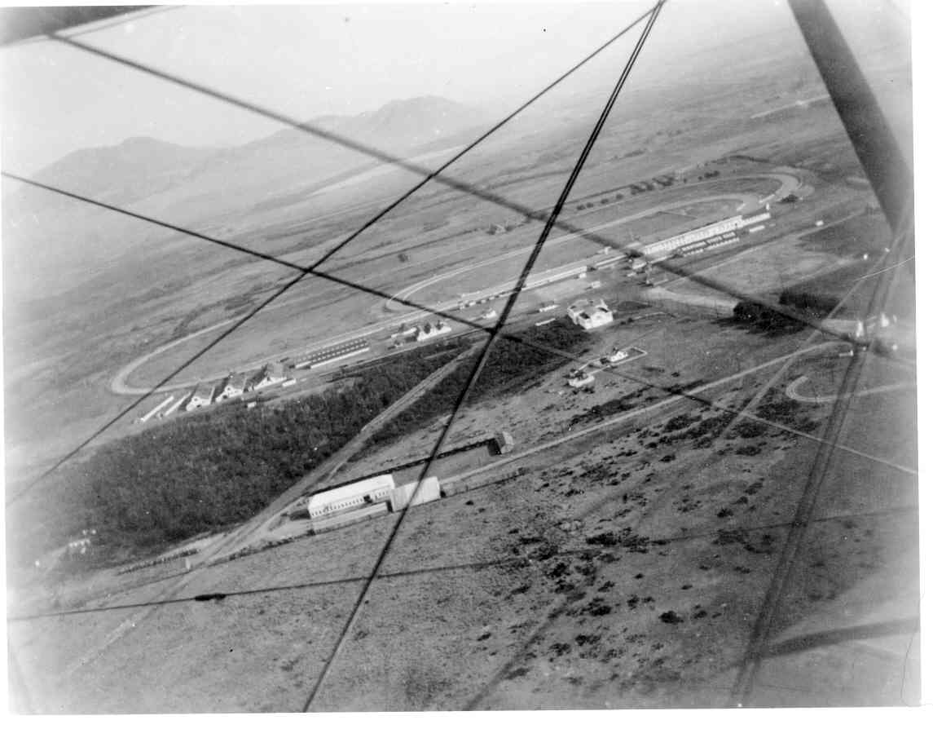

Aerial view, looking north c. 1927. Photo courtesy of the Montana Historical Society, Helena, MT. Photo #954-290

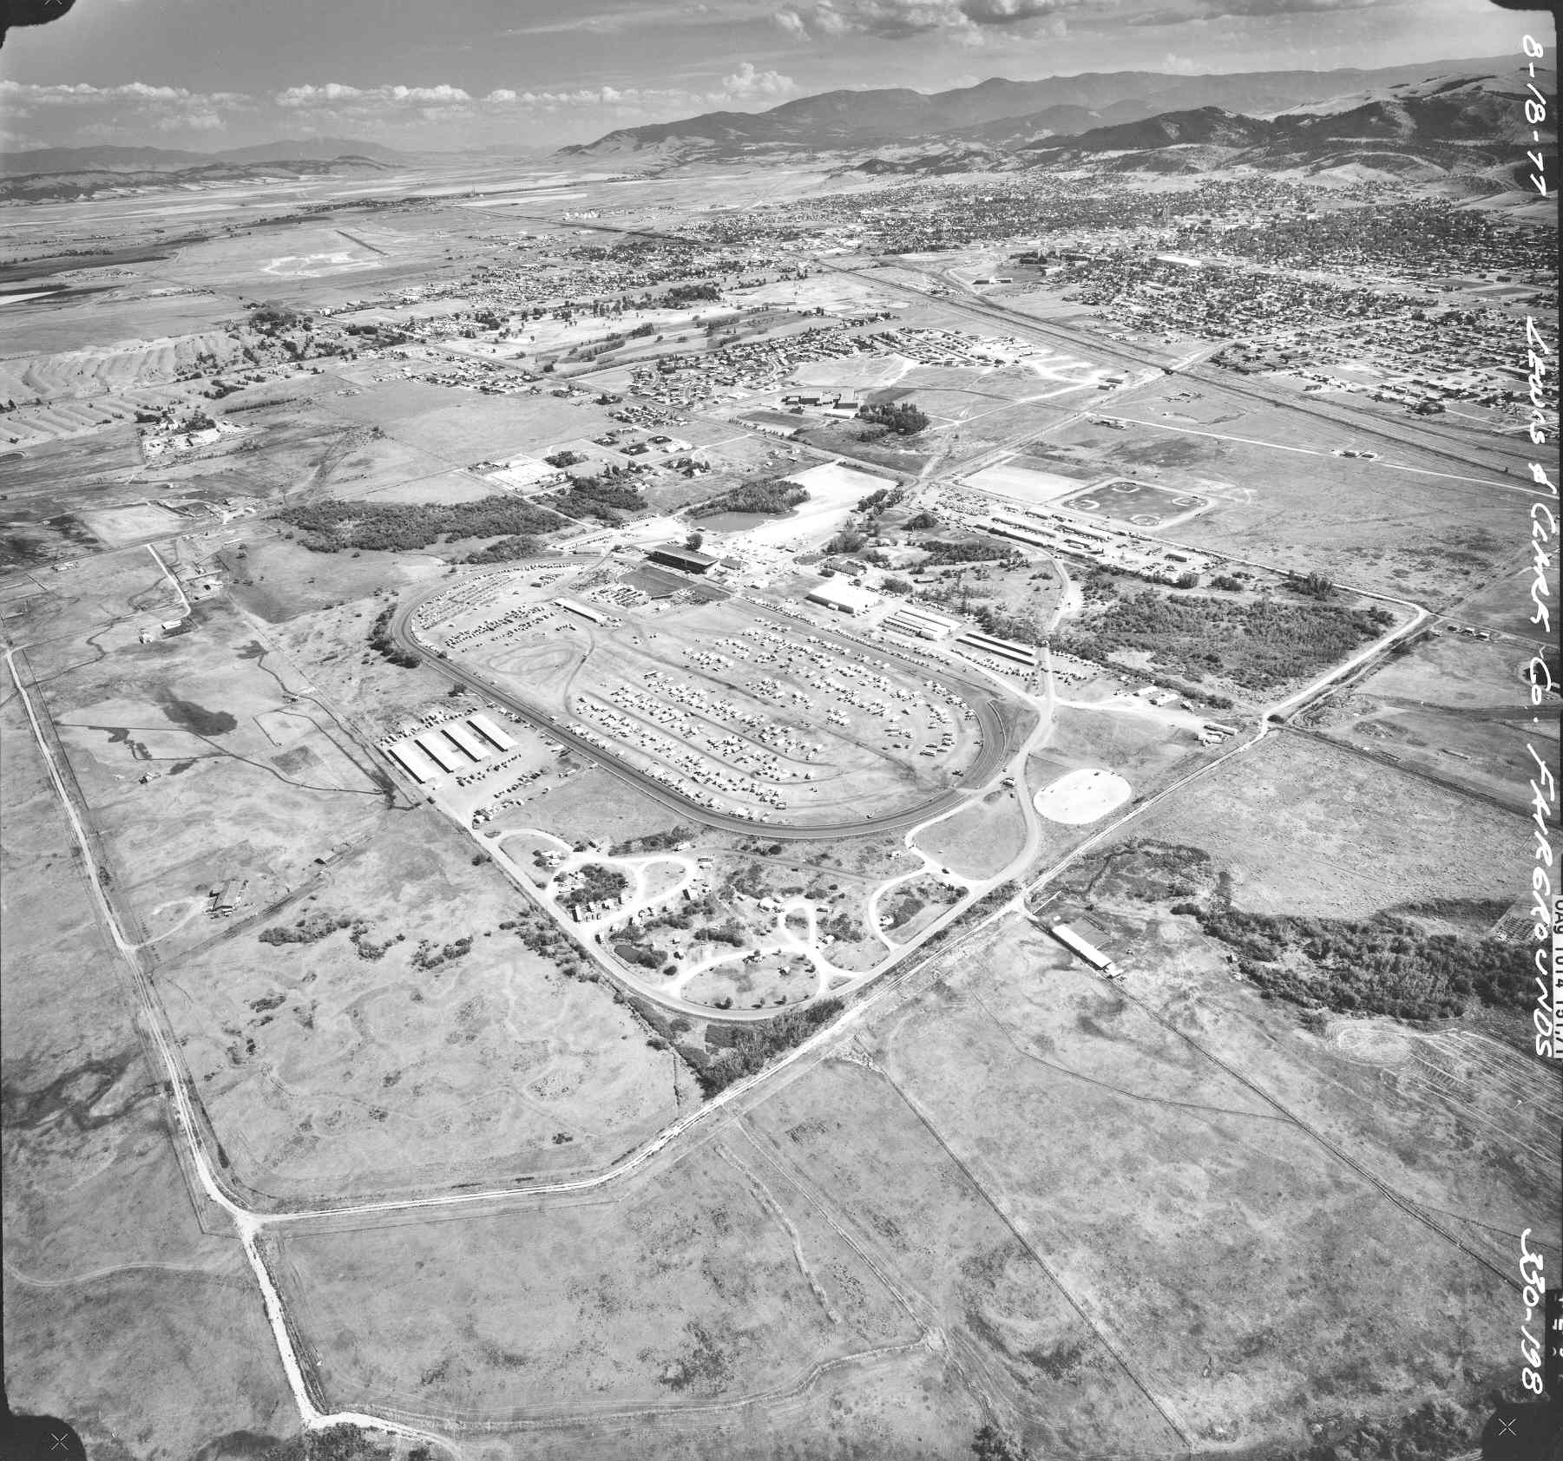

Aerial view to the southeast, 1977. Montana Highway Department Photo, filed with the Highway Photo Staff, MTDOT, Helena, MT.
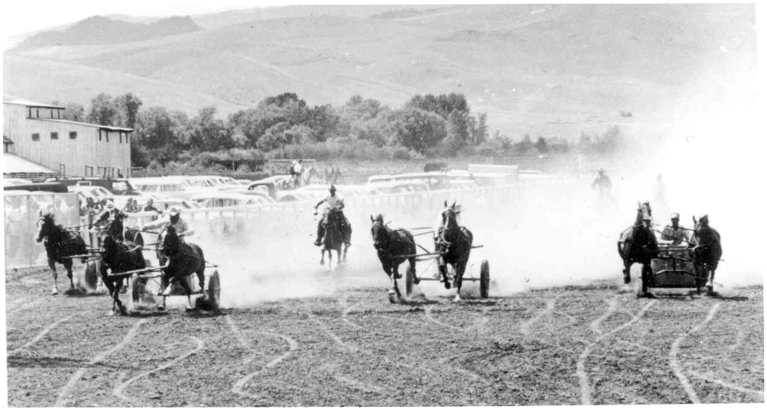

Chariot race, undated photo courtesy of the Montana Historical Society, “Helena – Last Chance Stampede Collection,” Helena, MT.

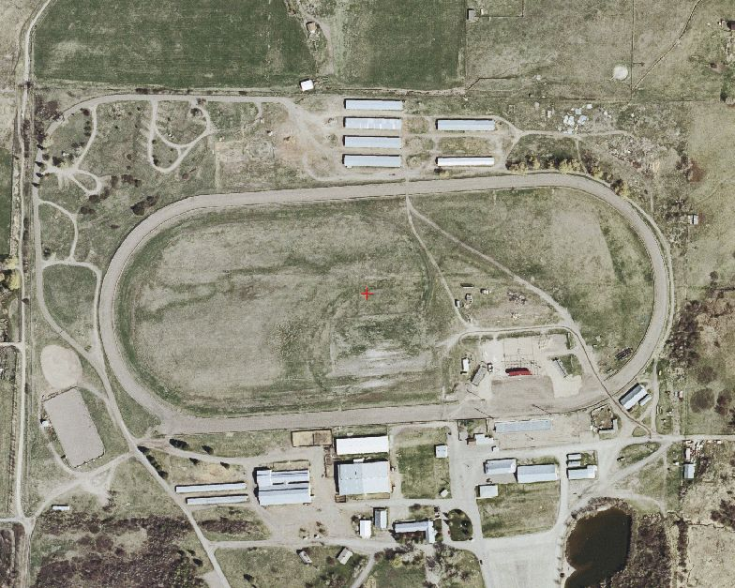

Aerial view of fairgrounds, 2004.
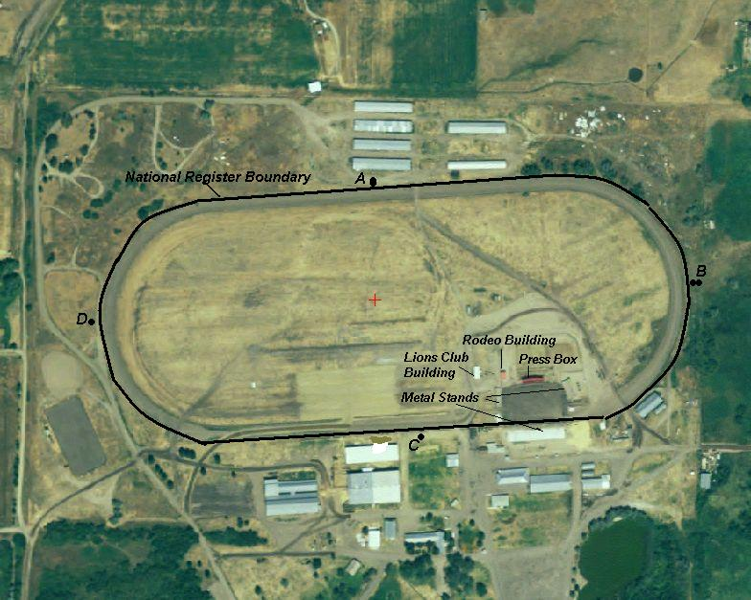

Aerial view showing National Register boundary and labeled resources, 2005.

1 “The History of Horse Racing,” http://mrmike.com/exlpore/hrhist.htm accessed 2/12/06.
2 http://www.triplecrowns.com/horse_racing/horseracing.html accessed 2/12/06.
3 “The Legacy of the Horse” International Museum of the Horse, http://www.imh.org/imh/kyhpl4b.html#xtocid388410 accessed 2/12/06
4 Ibid.
5 “The Dr. Jekyll and Mr. Hyde of the Old West,” Montana News Association Inserts, June 10, 1927.
6 Girl from the Gulches: The Story of Mary Ronan, ed. Ellen Baumler, Helena: MHS Press, 2002. p. 41.
7 Dick Pace, Alder Gulch: The Story of Montana’s Fabulous Alder Gulch. 6th printing, East Wenatchee, WA: Jursnick Printing, 1998. p. 56.
8 Joaquin Miller, An Illustrated History of the State of Montana, Chicago: Lewis Publishing Company, 1894. p. 470.
9 Montana Livestock Sketches, Larrabee (sic) Brothers folio. Microfilm 250, reel 32, Montana Historical Society Research Center, Helena, MT.
10 Leeson, 1182; Harvey family correspondence and legal documents collected and in the files of Charleen Spalding;
11 Miller, History of Montana, 288-289.
12 Patrick Morris, Anaconda Montana: Copper Smelting Boom Town on the Western Frontier. Bethesda, MD: Swann Publishing, 1997. p. 84-85.
13 Montana Newspaper Association Inserts, “Horses of Larabie’s Racing Stable fired Blood of Montanans Who Followed Ponies in the Nineties,” January 25, 1937.
14 Montana Newspaper Association Inserts, “Spokane, a Montana Horse.” May 19, 1932.
15 Ada Powell, The Dalys of the Bitter Root. Limited edition: 1989. p. 105-115.
16 Matt J. Kelly, Anaconda, Montana’s Copper City. Anaconda: Soroptomists, 1983, 31-33; Montana News Association Inserts, “Daly Gave Rider $10,000 Reward for Great Race,” March 6, 1941.
17 Mrs. Coady’s Two Mile House is advertised on a full page in the 1868 Helena Directory, p. 64. The Helena Herald, July 16, 1868, calls her place the Ten-Mile House. Presumably these are one and the same.
18 Helena Weekly Herald, October 15, 1868 and October 1, 1868.
19 Helena Weekly Herald, August 19, 1869.
20 Helena Daily Herald, July 8, 1870; Helena Daily Herald, August 12, 1870.
21 Helena Daily Herald, September 28, 1870.
22 “Racing Programme,” 1884, origin unknown, Carol Synness personal files; Helena Weekly Herald, September 27, 1877.
23 Helena Daily Herald, August 18, 1890.
24 The Daily Independent, August 29, 1890.
25 The Daily Independent August 22, 1890.
26 The Daily Independent, August 21, 24, 15, and 26, 1891.
27 W. E. Campbell. From the Quarries of Last Chance Gulch, Vol. II, 27; “Lewis and Clark County Fairgrounds Historic Sites Review,” unpublished report to the Helena/Lewis and Clark County Historic Preservation Commission, December 2003. p. 15, n. 23.
28 Report to the Board of Examiners, State Fair Board, 1918, p. 2
29 Helena Independent, September 1, 1927.
30 Winnett Times, July 21, 1930; Helena Independent, August 24, 1930.
31 Helena Independent, August 8, 1931.
32“Rule and premium list,” 29th Annual Montana State Fair and Lewis and Clark County Fair.
32 Great Falls Tribune, August 23, 1933.
33 MNAI, April 26, 1937; MNAI, November 8, 1937; Helena Independent, February 2, 1993; letter from State Board of Examiners, April 10, 1941.
34 Mike Gurnett, “Lewis and Clark Fairground Users,” Helena Independent Record insert, undated.
35 Correspondence from Allan Carter of the National Racing Museum to Carol Synness, February 6, 2006.
36 “Lewis and Clark County Fairgrounds Historic Sites Review,” unpublished report to the Helena/Lewis and Clark County Historic Preservation Commission, December 2003, on file at the Montana State Historic Preservation Office, Helena, p., 19.

